StateManagement in Asp.Net

Create New project 🡺 webForm🡺 Add New webForm🡺 ViewStateDemo.aspx

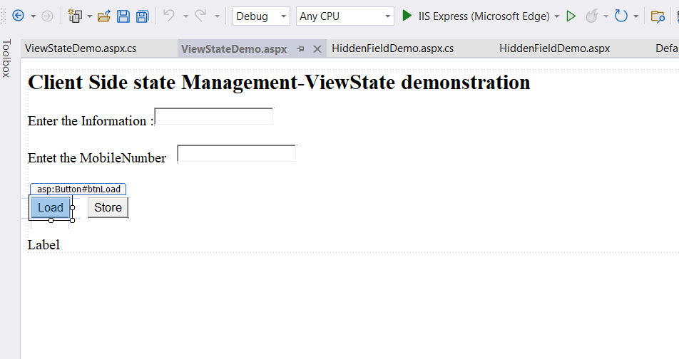

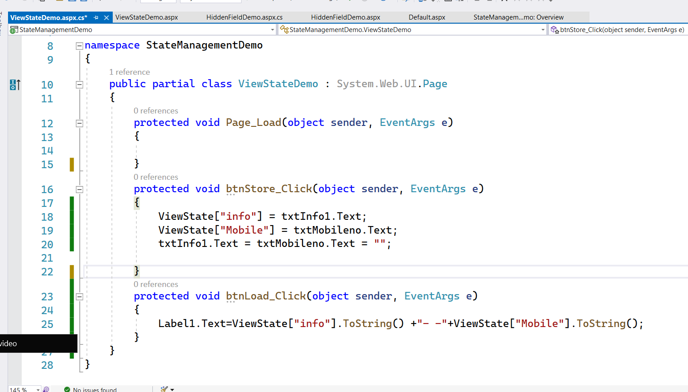

Add a New WebForm 🡺 HiddenFieldDemo.aspx

